The correctors

The property of the permanent magnets to be magnetically saturated allows superposition of the magnetic fields therefore permanent magnets can accept electromagnets as corrector magnets with no distortion of the their magnetic field. Figure1 is an isometric view of an OPERA model of a Halbach-type magnet surrounded by a window frame electromagnet acting as a corrector.
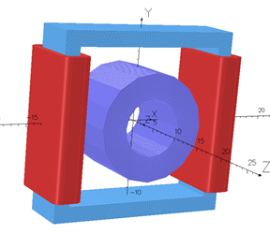
Figure1. A window frame magnets with two coils generates a normal dipole field which is superimposed on the field of the permanent magnet.
In this section we will present results from the 3D OPERA calculations which prove the following statements:
- The window frame magnets in spite their large aperture and short length, do not excite significant transverse magnetic multipoles except the ones are designed to produce.
- An excited window frame magnet placed around a Halbach-type permanent magnet as in Fig. 1 does not alter significantly the multipoles of the Halbach-type magnet (measurements are under way) and there is an almost perfect superposition of the fields of the two magnets.
- The Halbach-type magnets lend themselves easily to window-frame corrector magnets and do not interfere with possible access to the beam instrumentation which is placed in the short drift spaces between the magnets.
- Many Halbach-type magnets placed in conduct along their symmetry axis provide an almost perfect field superposition. (Measurements have been made thus no results from calculations will be presented).

The B_field of a window-frame electromagnet
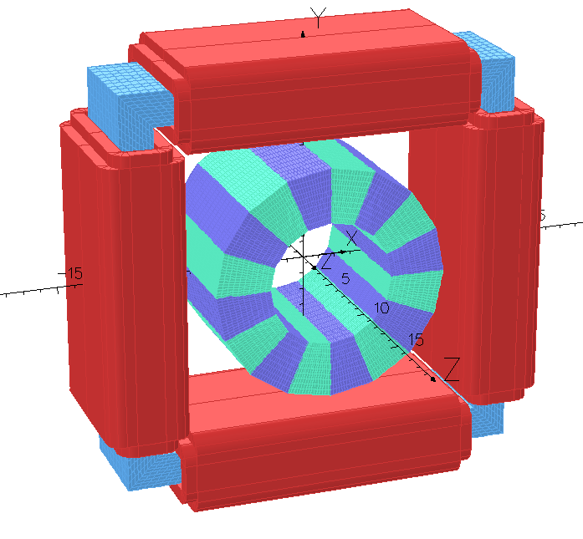
Figure 2 is a picture of 3D OPERA model window frame magnet to be used as corrector around a Halbach-magnet.

Figure 2. A window frame magnet with eight coils acting as normal and skew dipoles, and a normal quadrupole. By rotating the window frame by 45º we can generate a skew quadrupole instead of normal one.
Figure 3 is a projection on the x,y plane of the window frame magnet which shows that the maximum transverse directions of the corrector magnet surrounding a Halbach magnet is less than 30 cm.

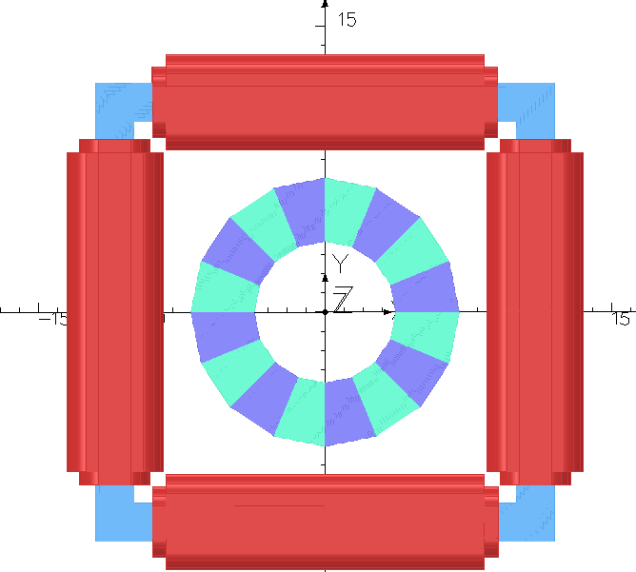
Figure 3. The projection of the window frame magnet on the x,y plane. The maximum transverse extend of the magnet is less than 30 cm.
Table I shows the integrated magnetic multipoles at R=1 cm of three different configurations of a quadrupole Halbach magnet and dipole window frame magnet. The 2nd row shows the integrated multipoles a dipole window frame magnet with no permanent magnet inside. Row 3 shows the integrated multipoles of a quadrupole Halbach-type magnet with no excitation of the dipole corrector and row 4 the multipoles of the dipoles window frame magnet excited, surrounding the quadrupole Halbach-type magnet. The permanent magnet material of the quadrupole magnet is NdFeB-N35 and the BH-curve for this material is shown in Fig. 4. The results from Table I show that the field of the window frame magnet is simply superimposed on the field of the quadrupole magnet.

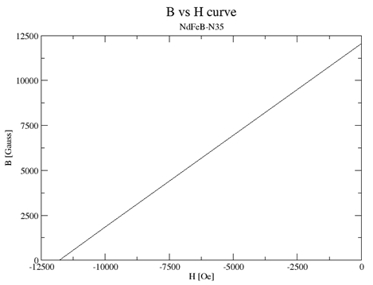
Figure 4. The BH curve of the NdFeB-N35 material.
Table I. The integrated magnetic multipoles of the window frame magnet by itself (2nd row) of a quadrupole Halbach type magnet (3rd row), and of the window frame magnet surrounding the quadrupole Halbach-type magnet.
 | Dipole [Gauss.cm] | Quad [Gauss] | Sext. [Gauss.cm⁻¹] | Oct. [Gauss.cm⁻²] | Dec. [Gauss.cm⁻³] | 12pole [Gauss.cm⁻⁴]
WFonly | 1931.14 | -0.0013 | 1.02 | 0.00003 | 0.014 | -0.000015
PM only | 0.000003 | 27798.5 | 0.000003 | 0.00000002 | 0.000003 | 0.037
WF_PM | 1933.7 | 27798.5 | 1.02 | 0.0123 | 0.017 | 0.016

Figure 5a is an isometric view few of permanent magnets of the Cβ arc with correctors. This view shows that the window frame magnets do not extend into the drift space between the magnets. Figure 5b is the projection on the yz plane of the six magnets showing in Fig. 5a. The current through the coils of the window frame magnet can generate the required correction field for the permanent magnets.
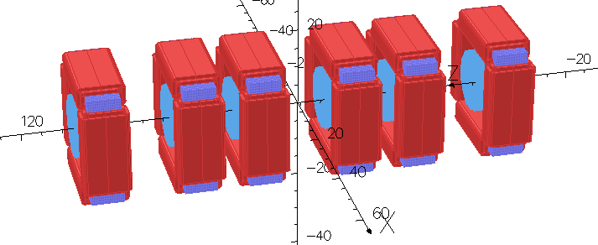
Figure 5a. Isometric view of six of the permanent magnets of the Cβ arc.
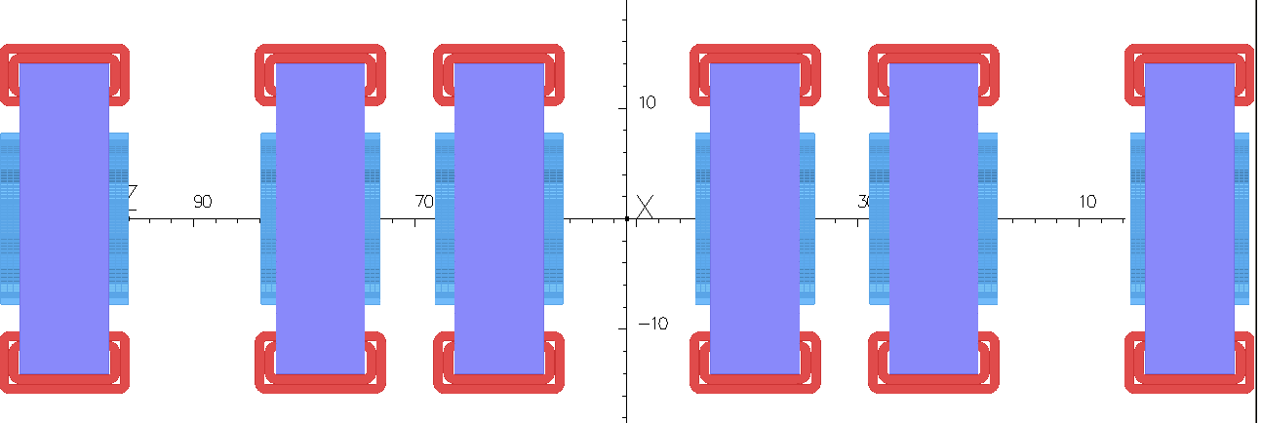
Figure 5b. Projection on the yz plane of the six permanent magnets of the Cβ arc.

